SKR MINI E3 V1.0

User Manual

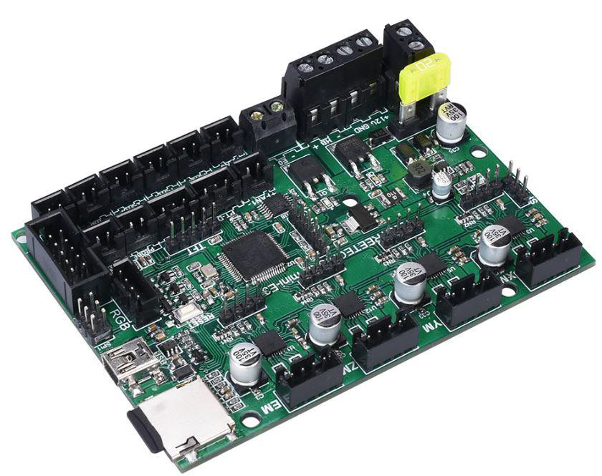

SHENZHEN BIGTREE TECHNOLOGY CO., LTD.

BIGTREE-TECH.COM

VERSION 1.0

AUTHOR: MERT CAPKIN

**Product Introduction**

BigTree Technology Co., Ltd. developed this high performance and customizable 3D printer controller board to provide a direct replacement for the Ender 3 which has more options.

**Main Features**

1) The board is controlled by a STMicroelectronics ARM Cortex M3 32-bit STM32F103RCT6 MCU. This chip has a Maximum Clock Frequency of 72 MHZ.

2) Supports 2.8 inch, 3.5 inch color touch screen and original Ender3 printer LCD12864 screen.

3) Integrated UART TMC2209 stepper motor drivers.

4) Supports open source firmware Marlin2.0. This means it is convenient for users to customize their firmware and develop it. The firmware is upgraded with a SD card, which is very convenient and efficient!

5) Dedicated ports for BL Touch, stallguard, UART and SPI.

6) High voltage input means heated bed current draw can be reduced to 1/4, without power loss.

7) Supports functions such as BL touch, RGB LED, stallguard, printing after power failure and power off after print finished.

8) The layout of the PCB is optimized for heat dissipation.

**Board specifications**

1) Size: 100x70.25mm

2) Input voltage: 12V-24V DC

3) Max. allowable total power usage: 180W@12V, 360W@24V

2

**Dimensions**

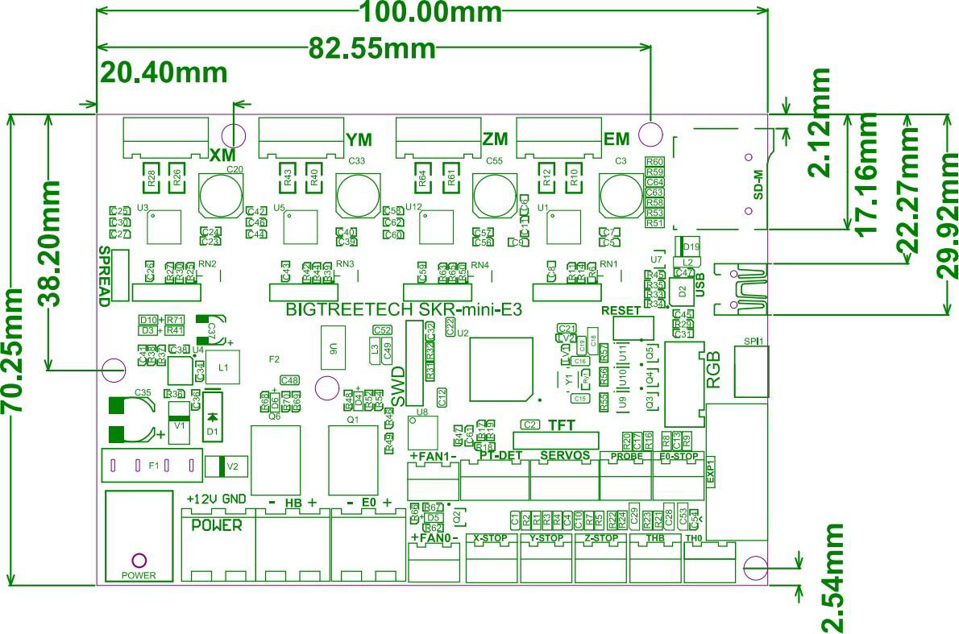

3

**Wiring**

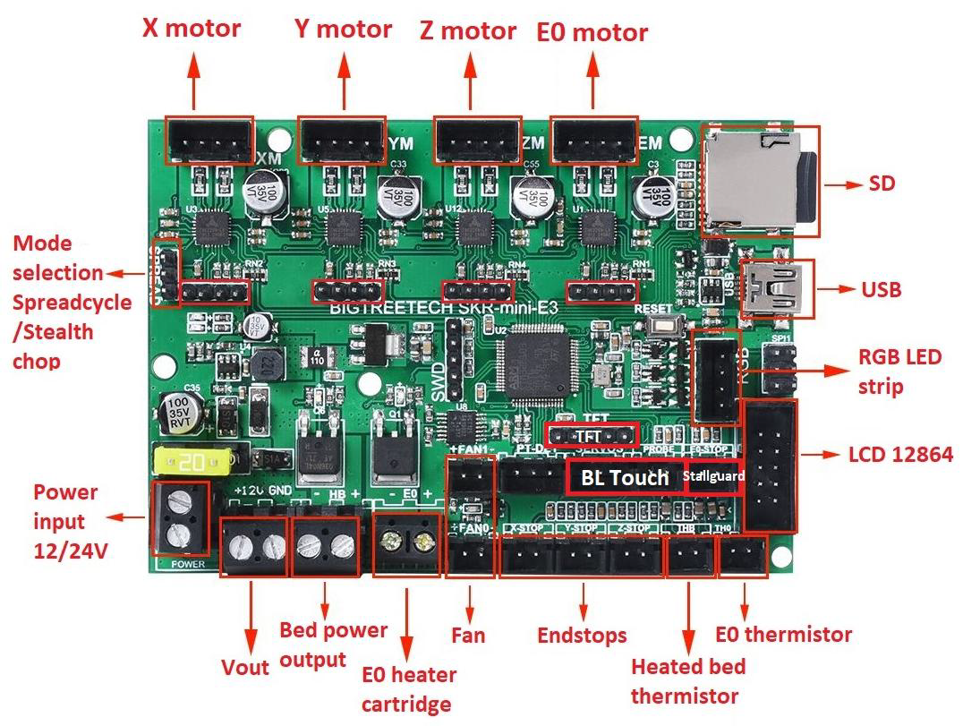

4

**Pins**

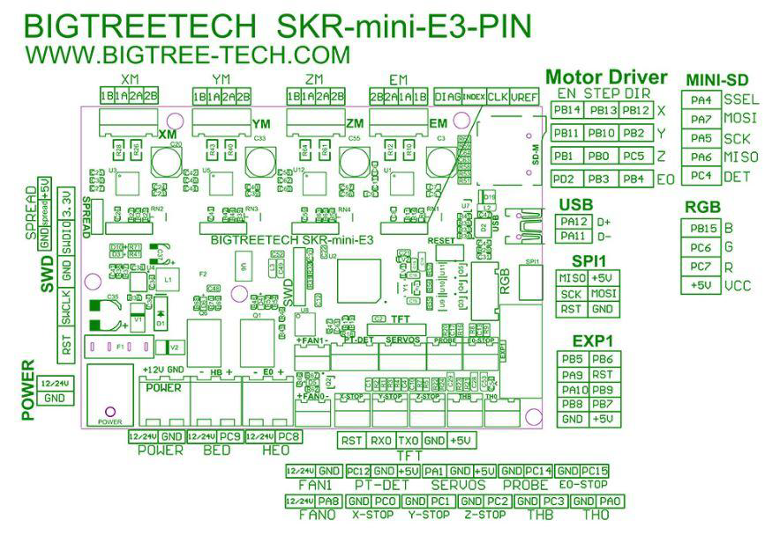

5

**Onboard LED information**

The red LED D3 is the power indicator light. The LED is on when the board is powered.

The red ‘status’ LED D10 flashes when the firmware is updated, and stops flashing when the update is complete.

The green LED D6 is the heated bed status indicator light. It is on when the heated bed is powered and off when the heated bed is not powered.

The green LED D4 is the extruder status indicator light. It is on when the extruder is powered and off when the extruder is not powered.

The green LED D5 is the fan (Fan0) status indicator light. It is on when the fan is powered and off when the fan is not powered.

**Communication between board and computer**

After the board is connected to the computer through the USB cable, the computer will automatically install the needed driver. After the driver installation is completed, the board can be identified for data transmission. If the installation fails, you can download the needed driver from here:

https://github.com/bigtreetech/BIGTREETECH-SKR-MINI-

V1.1/tree/master/firmware/mapleDrv-USBdriver

Download the file named mapleDrv for installation. After the driver installation is completed, open the ”Device Manager” to see the port to which the board is connected. If you see the same as in the picture below, then the board is succesfully connected.

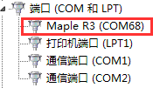

6

**Stepper driver and peripherals configuration**

**1) Spreadcycle/Stealthchop**

There are two ways to set the mode.

First method:

Put a jumper on the pins to select the desired mode.

For Stealthchop: Connect ‘spread’ and ‘GND’

For Spreadcycle: Connect ‘spread’ and ‘5V’

Second method:

Modify the firmware to select the desired mode.

**2) Stepper driver expansion pins**

Each driver is reserved with four pin expansion ports, respectively DIAG, INDEK, CLK, VREF from left to right. Users can add DIY functions according to their own preferences, such as DIAG as ENDSTOP function and so on.

1. **BL Touch**

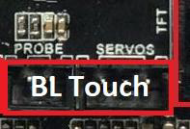

For BLTouch use the ‘PROBE’ and ‘SERVOS’ pin to connect.

**4) Power failure module**

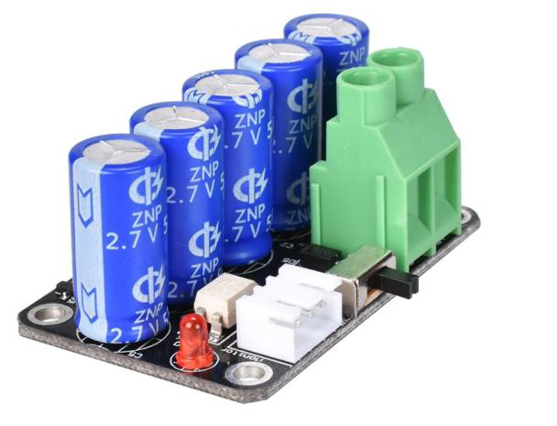

To make use of the power failure detection feature you need a BIGTREETECH MINI UPS V1.0 module. See the user manual for the power failure module for more information. You can find it here:

<http://github.com/bigtreetech>

7

**5) Automatic shutdown after print**

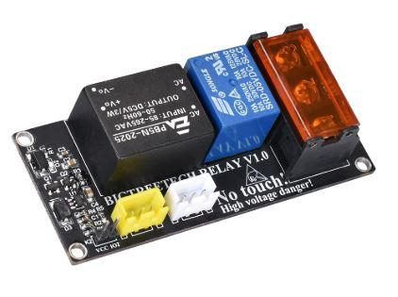

To make use of the automatic shutdown feature you need a BIGTREETECH Relay V1.0 module. See the user manual for the module for more information. You can find it here:

http://github.com/bigtreetech

**Firmware**

By default there will be a firmware installed on the board, which is optimized for Ender 3. It is also possible to make changes to the firmware. You can find the needed firmware files on our Github page.

BigTreeTech firmware: http://github.com/bigtreetech

**Marlin2.0 firmware update method:**

After downloading the files, use Visual Studio Code to open the project for compilation. Customize the firmware and compile it. Check for errors. If there are no errors, find the firmware.bin file. Copy it to the SD card and plug the SD card in the board. Reboot the board, wait for about 10 seconds before doing anything else with the board.

For detailed steps, please check this document:

http://www.dropbox.com/s/ppjfflhf3j5yzh2/MarlinV2.0%20SKRV1.1%20instruction.docx?dl=0

Note: File name cannot be changed, firmware.bin must be lowercase!

8

**Notes**

1) Ensure that all wires, jumper and drivers are correctly plugged in before power-on.

2) To avoid damage, do not plug or unplug the stepper drivers when the board is powered.

3) Double check all your connections before powering up the board.

4) At the moment printing from a USB flash drive is not supported.

5) SKR MINI E3 V1.0 is a motherboard designed specifically for the Ender 3D printer.

If you want to use another machine, please refer to the corresponding electrical parameters of Ender3 (such as heated bed power, extruder cartridge power, etc.).

The electrical parameters of other machines should never exceed the electrical parameters of the Ender 3. Our company will not compensate for any losses caused.

9